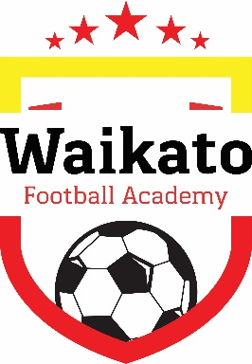

Junior Program
This program is for players aged 7 – 10 years of all skill levels. The program is open to players from any club or school.
Players are grouped by age and skill level for the term. Players will be coached on basic skills – increasing in intensity and difficulty as they development and improve.
The program will cover:
- Juggling
- Ball Control
- Heading
- Passing and Receiving
- Dribbling and Running with the Ball
- Turning and Shielding
- Defending
- Shooting and Finishing
- Tactics and Teamwork

Junior and Elite Youth Individual Development Programs

Elite Youth Program
This program is for players aged 11 – 14 years with a higher skill level, who are playing either club or school football, or both including youth federation.
The youth program will along with skill development include game knowledge, nutrition and fitness
The program will cover:
- Individual Techniques
- Group Tactics and Team Play
- Game Knowledge and Understanding
- Player Attributes
- Strength and Conditioning
- Nutrition for elite players
- Game exchanges with other Elite Squads

What to wear:
All players are required to purchase the training kit which consists of shirt, shorts, socks and jacket (jacket required for winter terms only).
Having a training kit ensures players feel part of an elite group of players.
Players also require shin pads, boots and a water bottle. Soft soled shoes can also be brought for wet days if an indoor venue is available.
Venues/Facilities
We endeavour to be located at venues with all-weather facilities. Due to availability of school’s indoor resources, at times we may need to cancel a session.
Costs:
Prices vary based on the number of weeks per term and range between $100 - $120.
Training kit prices are quoted on our website.

